1. 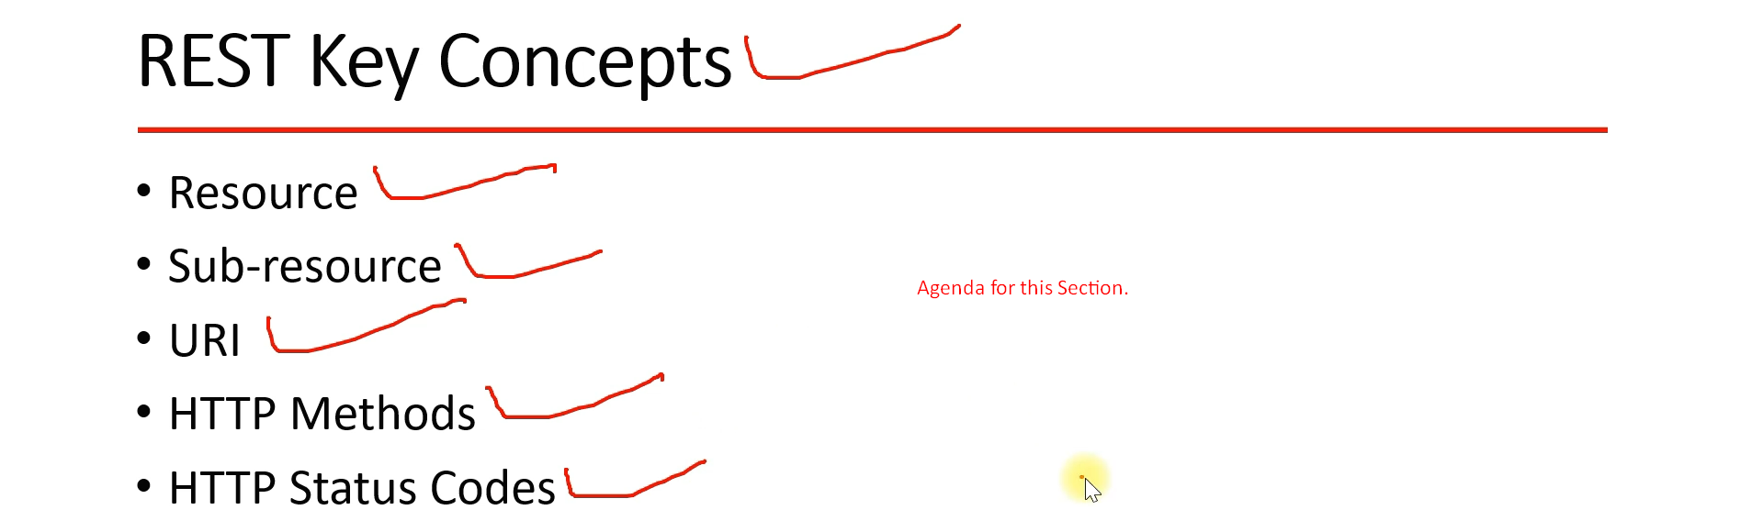
2. 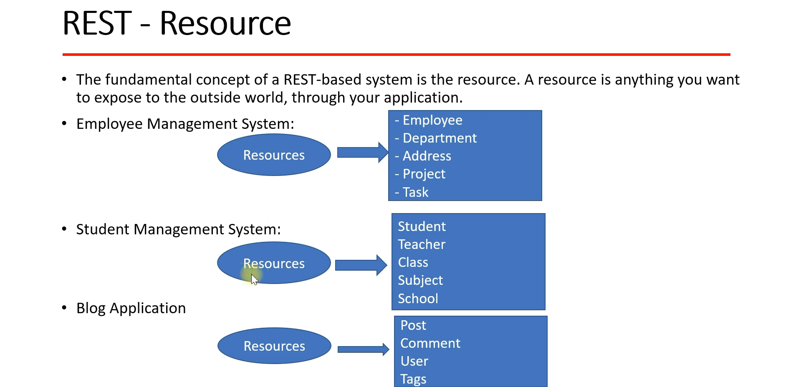
   1. Considering we’re developing an “Employee Management” System.
   2. Now what are possible resources in this system or domain?
   3. 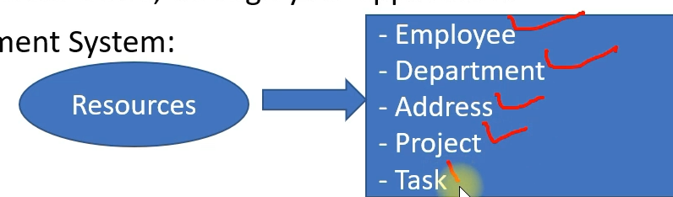
   4. So, we create a CRUD API for each resource.  
      And a client basically consumes REST API for these resources.
3. **Now how a client identifies a unique resource**?
4. **Solution**: URI. For each resource, there is a unique URI.  
   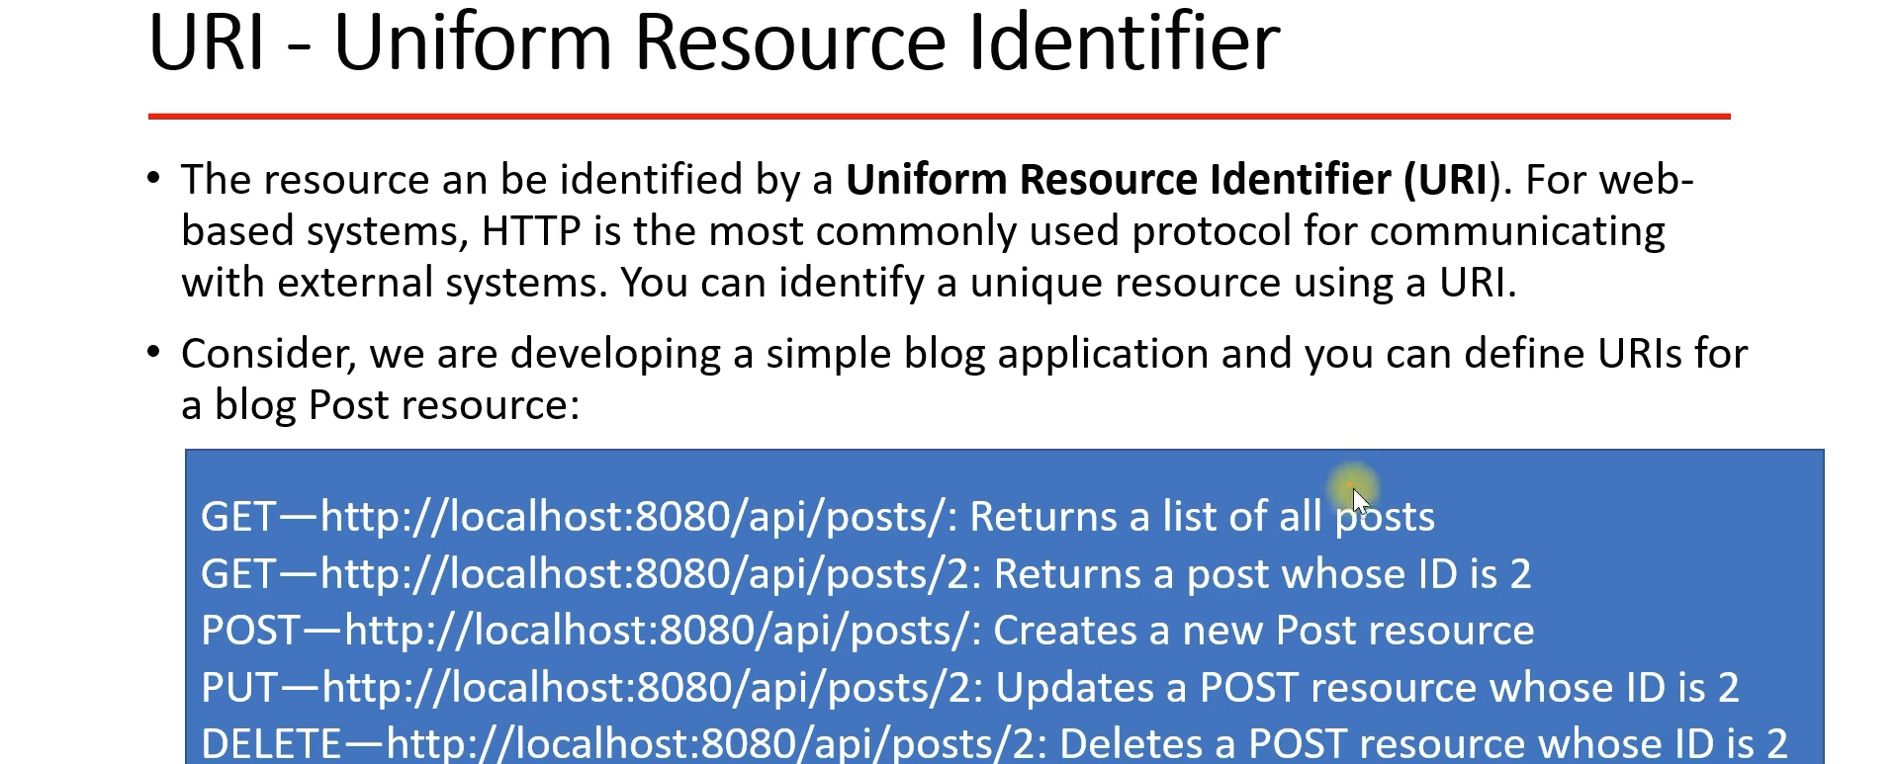
5. Sub-Resource.  
   